1. 0/1 Knapsack Problem: Packing a Survival Kit backpack

You are preparing a survival kit backpack for a hiking trip. The backpack can hold a maximum weight of 15kg, and you have a list of items with their respective weights and survival values (how useful they are). Determine which items to take so that the total weight does not exceed 15 kg and the survival value is maximized. Write a C++ program to implement 0/1 Knapsack algorithm to compute the best combination of items for maximum survival value.

You must choose from the following items:

|  |  |  |
| --- | --- | --- |
| **Item** | **Weight (kg)** | **Survival Value** |
| First Aid Kit | 5 | 60 |
| Water Bottle | 3 | 50 |
| Food Supplies | 4 | 70 |
| Warm Clothes | 6 | 80 |
| Flashlight | 2 | 30 |
| Map & Compass | 1 | 20 |

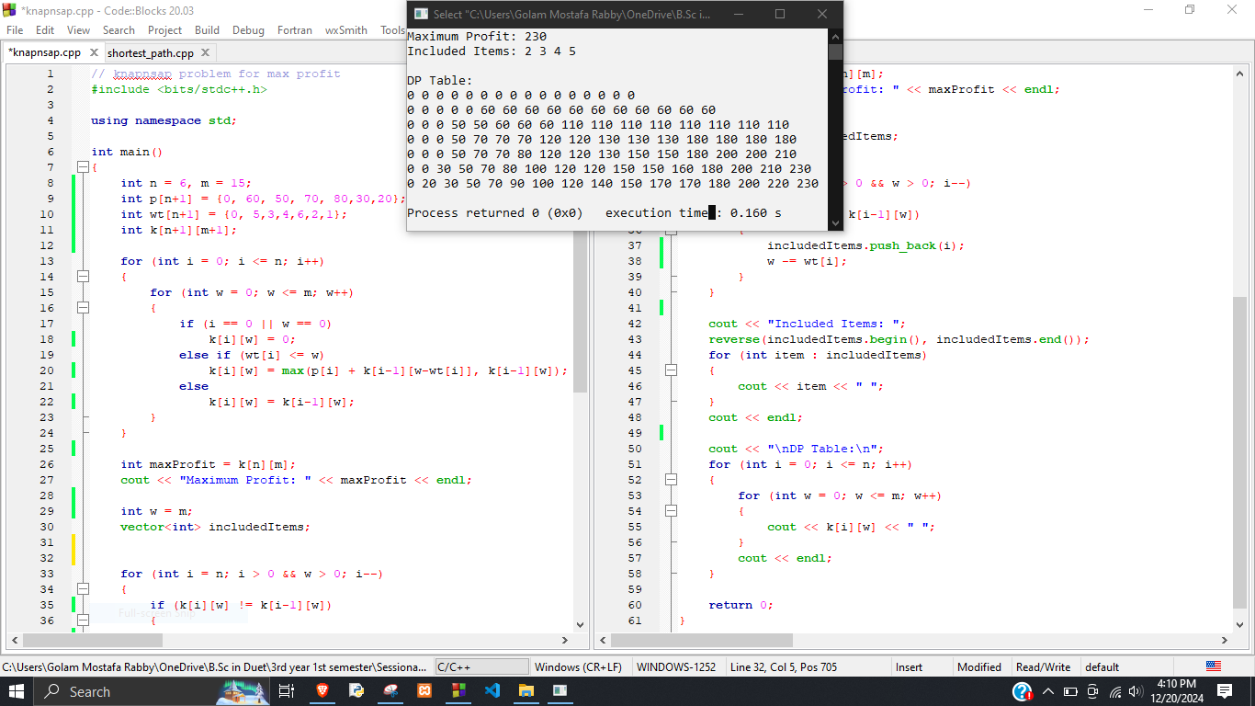

1. Write a C++ program to implement Floyd-Warshall algorithm to find the shortest paths between all vertices in the following directed weighted graph.

